
Caring for Your Green Roof

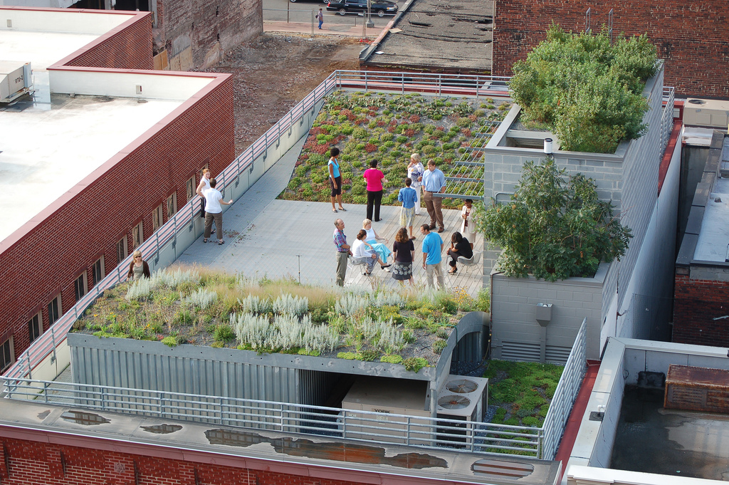
Green roofs can be fun and easy to maintain. If you follow these simple instructions you should see your plants growing in just a couple of weeks.

Ask your mom or dad to help you take care of it. Once you get it home, remove the plastic and put your green roof in a bright window to soak up plenty of sunlight. Plants need the sun to grow!

Sprinkle 1/2 to 3/4 cup of water on it when the soil dries out. Don’t put too much water on it because it’s only cardboard.

Have fun!

American Society of Landscape Architects
636 Eye Street, NW
Washington, DC 20001
202-898-2444
www.asla.org

